**Managable Interface :** The “Managable” Interface is used for all collections for the program. The interface allows for adding, removing, and sorting all components in each collection.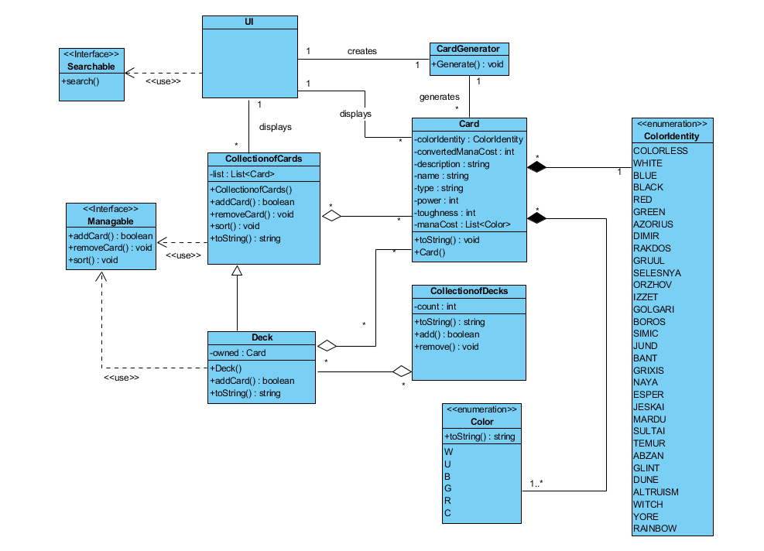



**Searchable Interface :** The “Searchable” Interface is used for the UI, in order to search through elements of the program.

**UI Class :** The UI class is used for user interaction. Through the UI, the user will be able to edit their main collection, create new decks, and edit any current decks or collections. The UI also uses the “Searchable” Interface to allow the user to search for cards, decks, and search through their collection/decks for specific cards.

**Color Enum :** The “Color” enum is used to identify the colors of each different mana type.



**ColorIdentity Enum :** The “ColorIdentity” enum is the name of the Color Identity of a card. This will mainly be used for sorting cards when searching.

**CardGenerator Class :** The “CardGenerator” class is run at the startup of the program, and reads through the JSON file. It sorts through the file and creates every card with the correct data. 

**Card Class :** The “Card” class represents a card object. Cards contain data for the card color, color identity, mana cost, name, type, power, toughness, and description/effects. It also includes a toString() method to display a card’s information.

**CollectionOfCards Class :** The “CollectionOfCards” Class contains a list of cards. It uses the “Managable” interface for use of adding, removing, and sorting the collection. This list can be accessed by the user to view and change their collection. They can add and remove cards, sort the list, and mark certain cards for trade.

**Deck Class :** The “Deck” Class represents an actual deck. This class extends the “CollectionOfCards” Class. Decks are created by the user.

**CollectionOfDecks Class :** The “CollectionOfDecks” Class is a list of all the current decks currently owned by the user. This will be used for displaying any decks in the UI.